# Introduction

Blood donation is very important for public health. It helps provide blood for people who need it during surgeries, accidents, or long-term illnesses.  
But in many places, there is not enough blood because only a few people who can donate actually do it.  
This project looks at how often people donate blood in a certain area. It will study things like age, gender, awareness campaigns, and seasons to find out what affects people's decisions to donate.  
The idea is that younger people and those who see special awareness messages are more likely to give blood.

**Project Overview**

A responsive and user-friendly Blood Bank Management System designed to facilitate blood donations and requests efficiently. This project is designed to connect blood donors with those in need.

The Home page gives an overview of the platform and its goals and explains the mission behind the initiative.

The Admin panel manages user details and tracks blood donation history.

Users can reach out through the Contact page for help finding blood. The system includes a Login & signup page for secure access, and a More page for general inquiries and user feedback.

Users can create accounts and log in securely. To ensure security and privacy, the website has private routes that only authenticated users can access.

This feature protects sensitive information and restricts unauthorized access. The website includes testimonials from well-known personalities who have used the services.

These reviews provide social proof and build trust among potential clients.

**Flowchart**

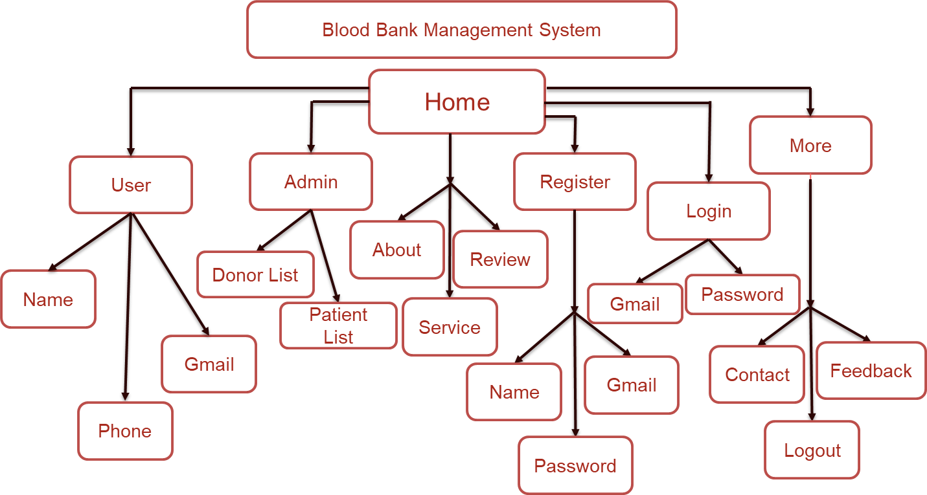

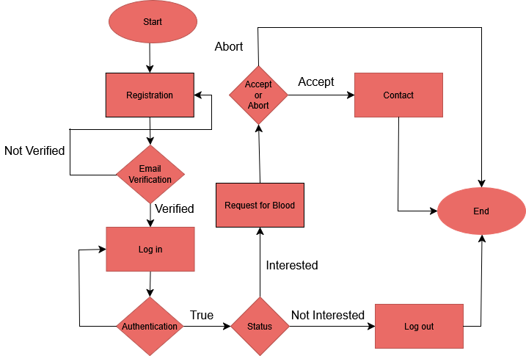

# Technology Stack

Frontend:

* HTML
* CSS
* JavaScript
* React
* Tailwind

•Firebase for authentication

Backend:

* JavaScript
* MongoAtlas Database

# Screenshots

Home

This is the homepage or main page of a donate blood website.

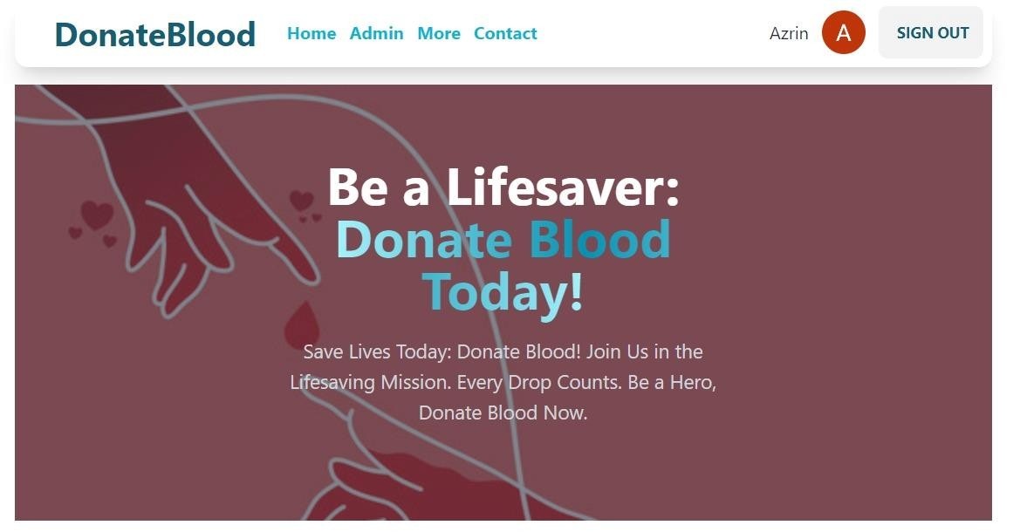

Service

Here are some of the services and achievements given below-

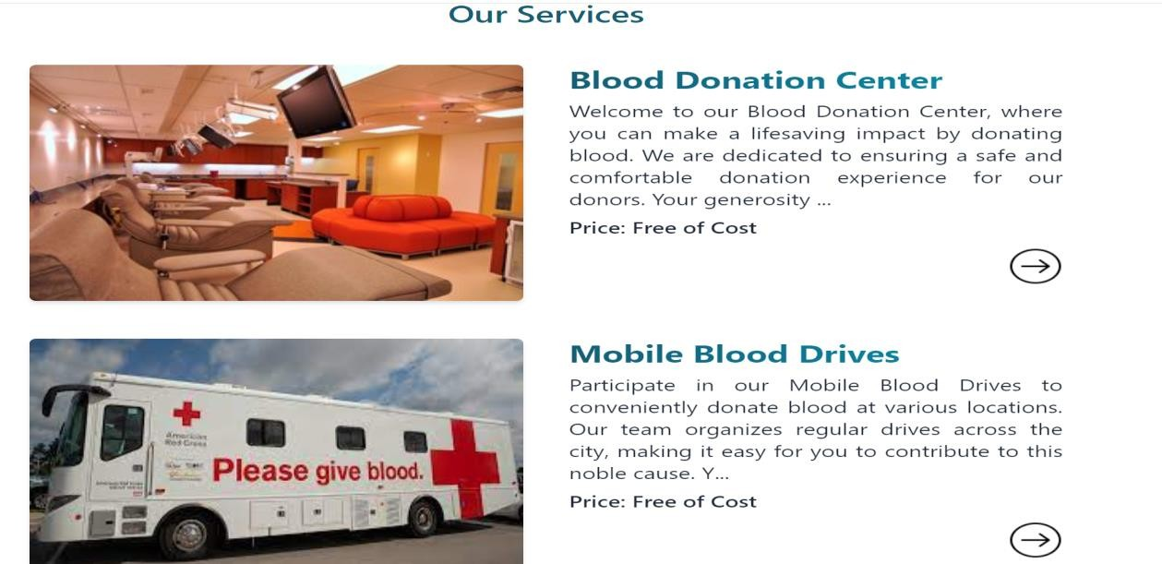

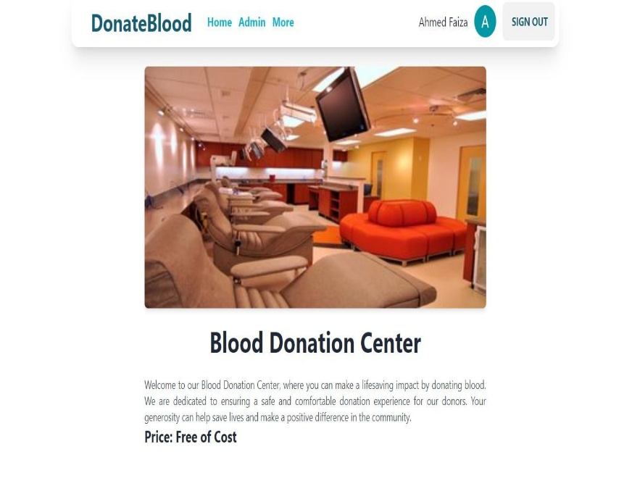

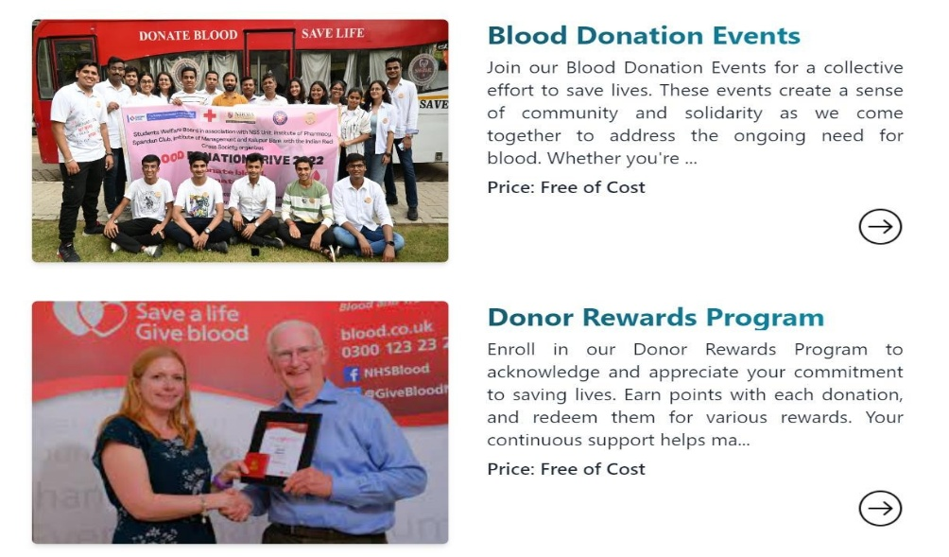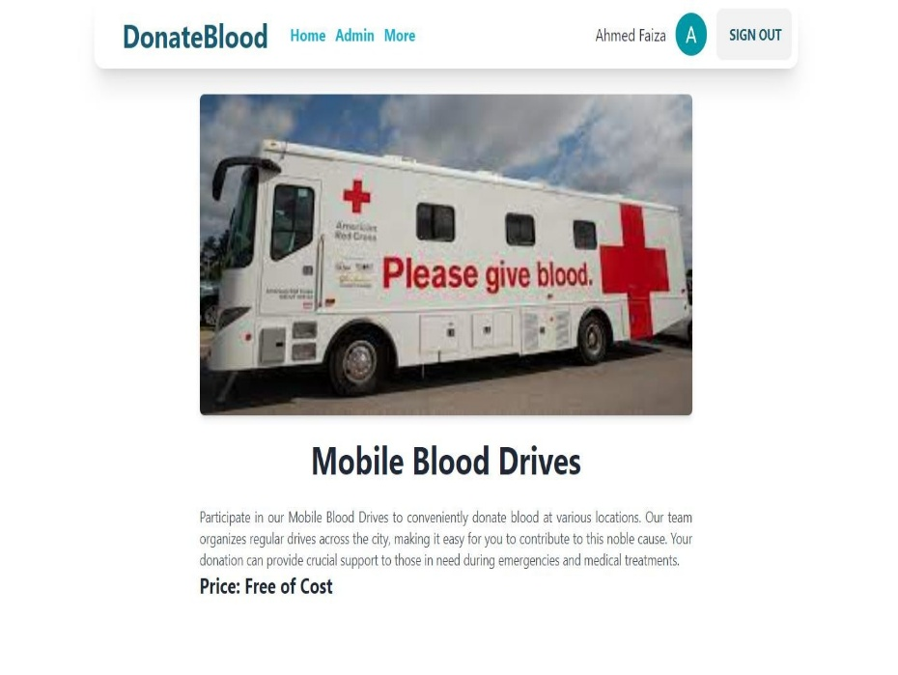

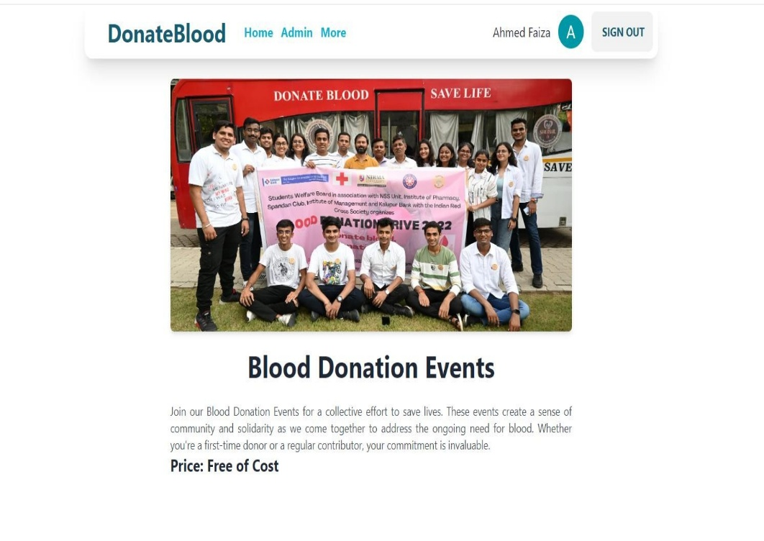

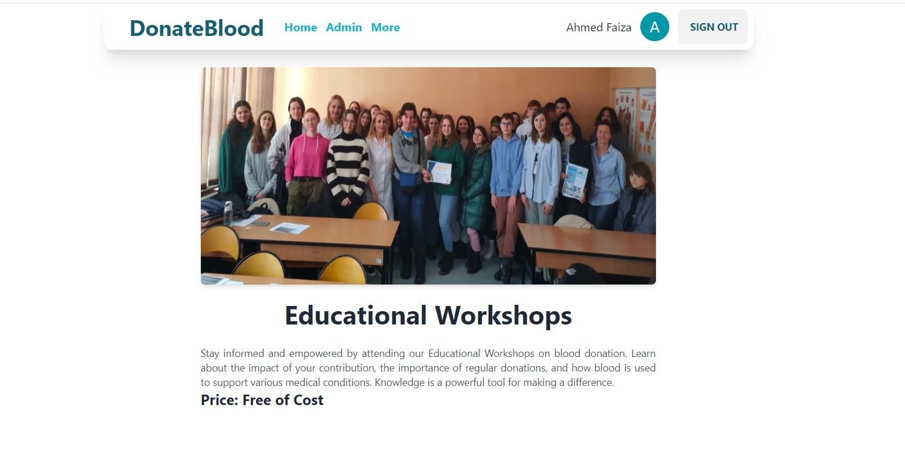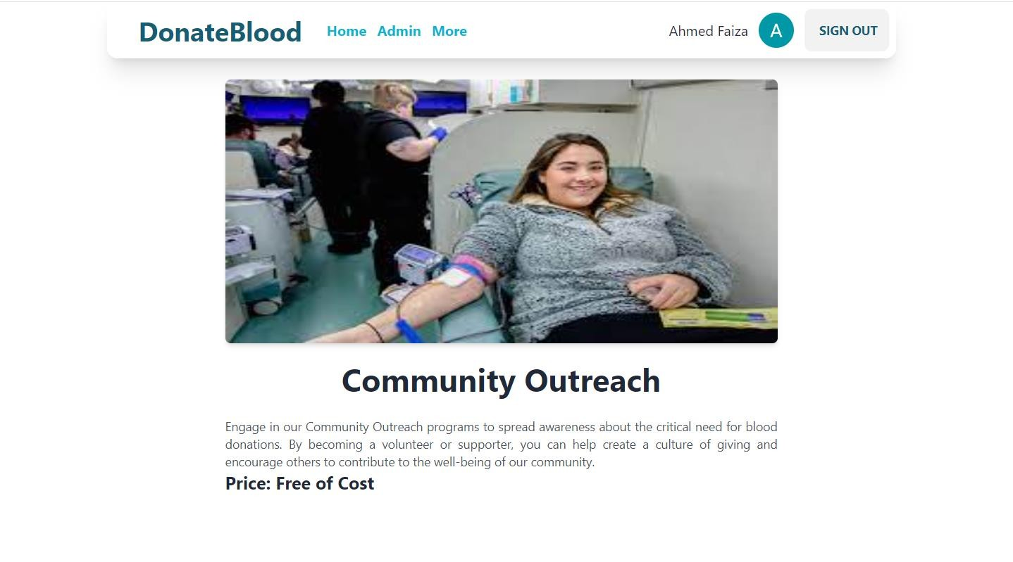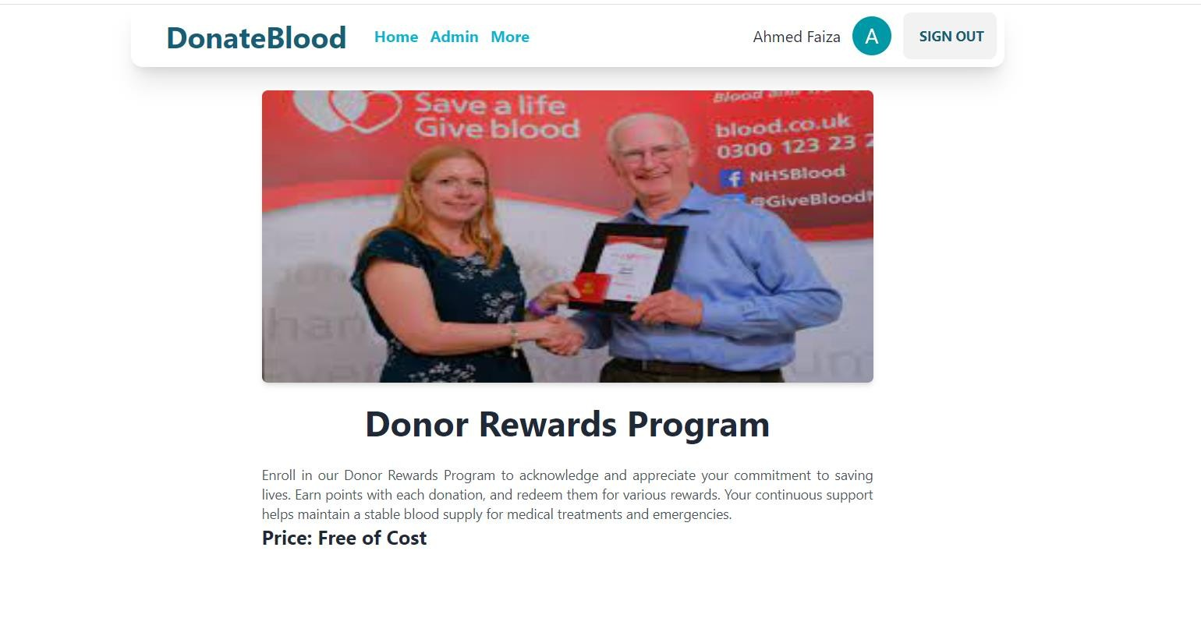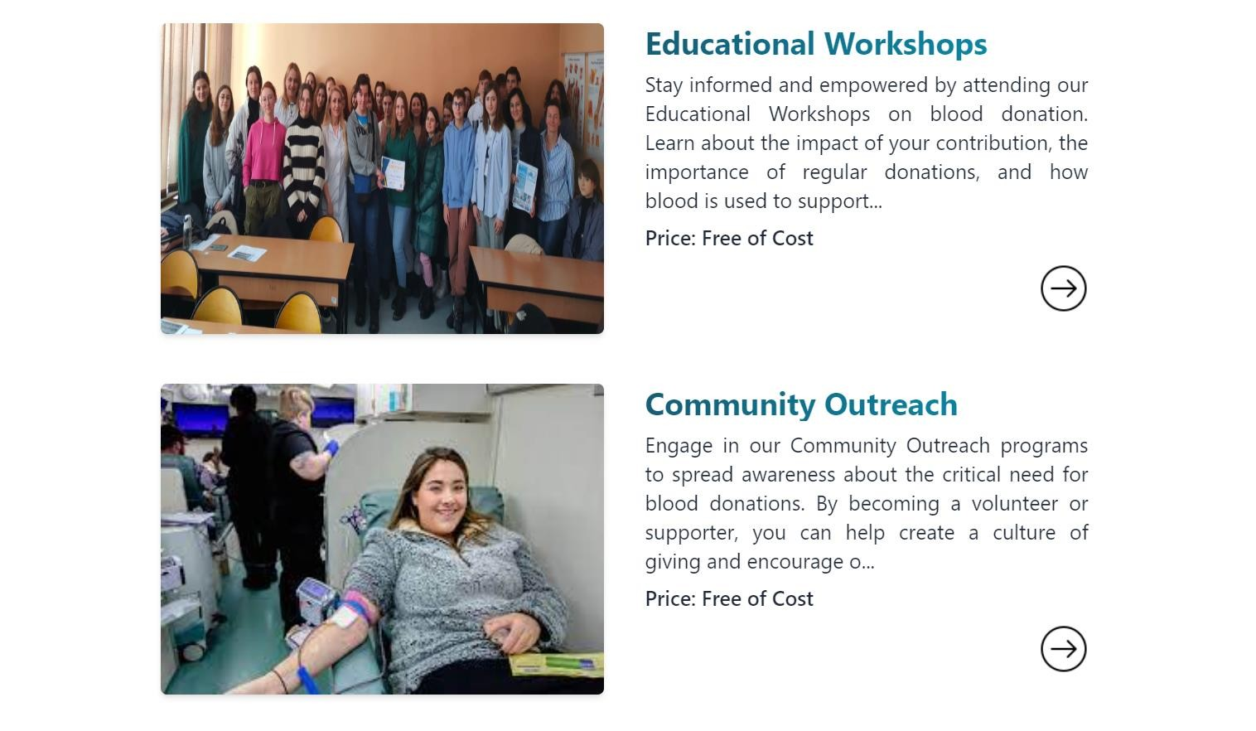

Patient Review

Here are some of the valuable reviews about the website.

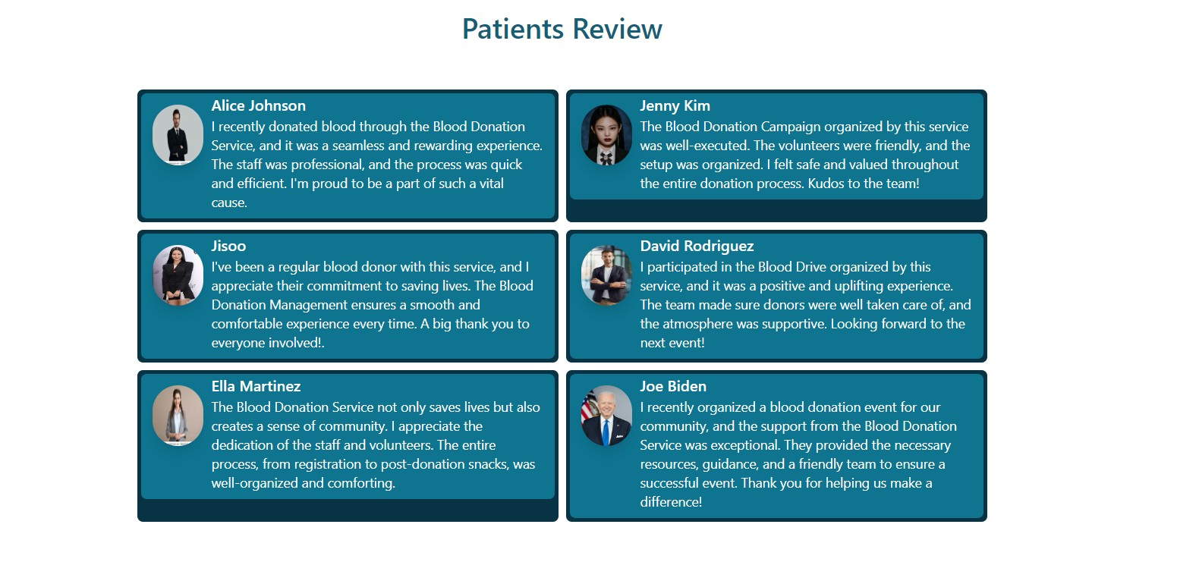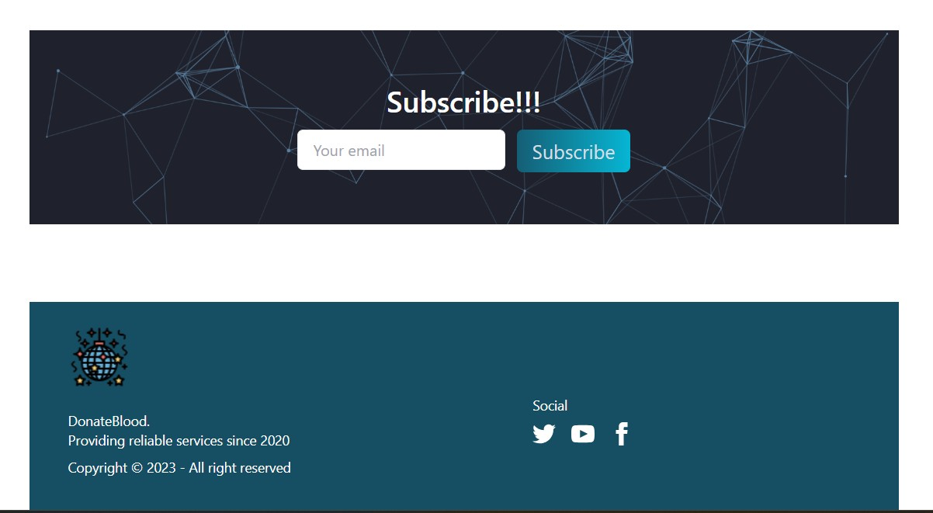

Donor Details

Here the details of the donor are given to store the information in the database.

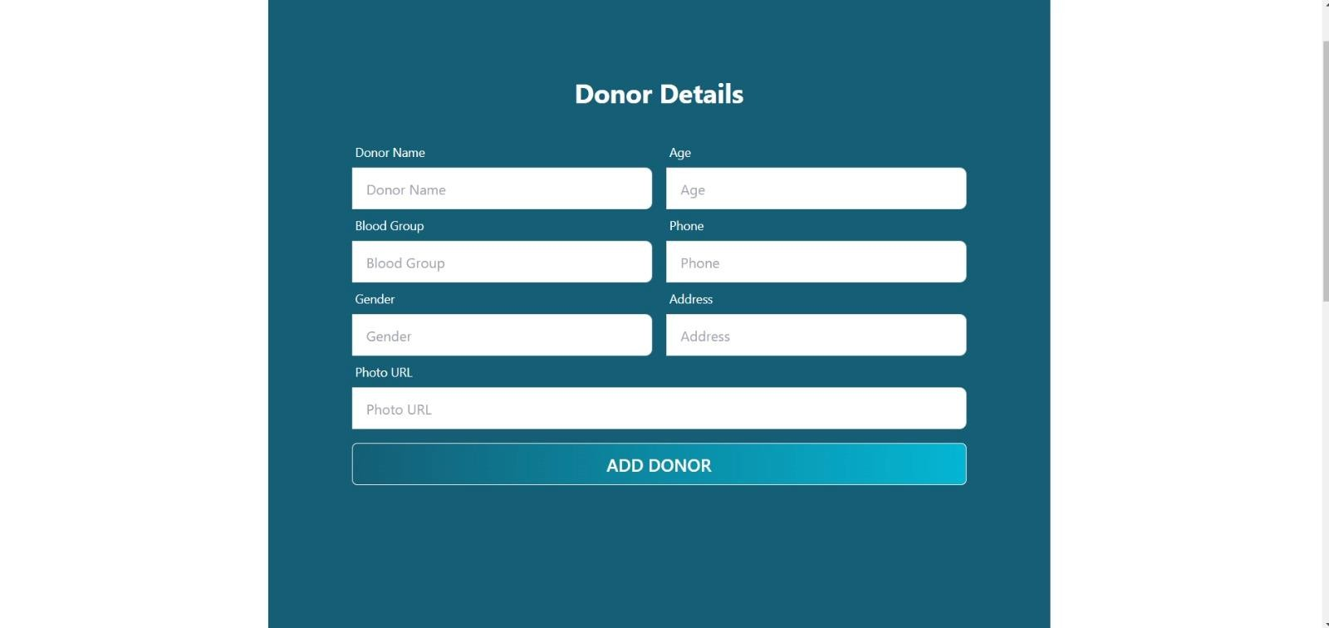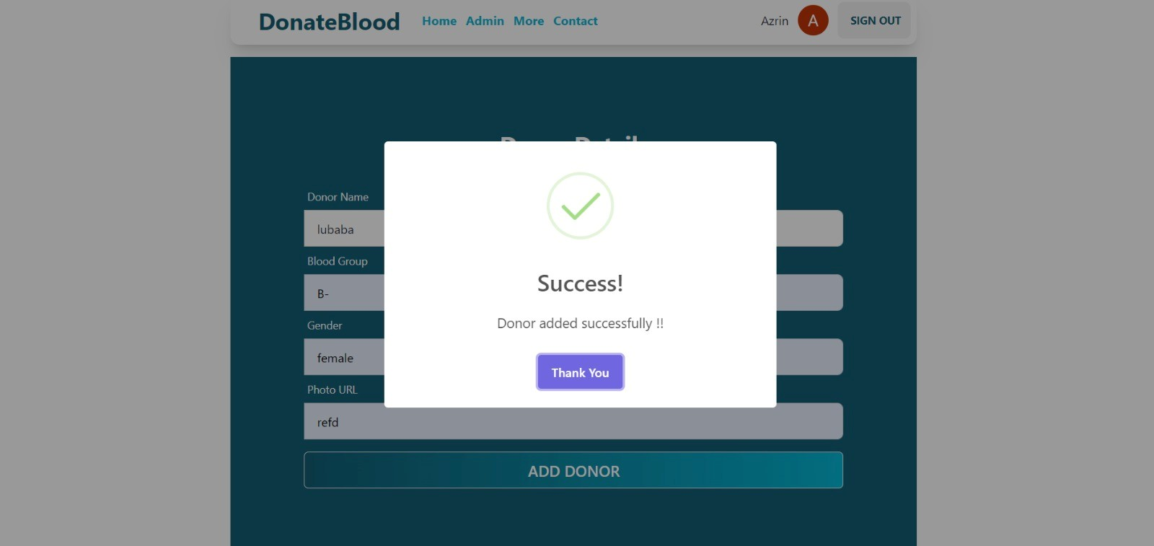

Patient Details

Here the details of the patient are given to store the information in the database.

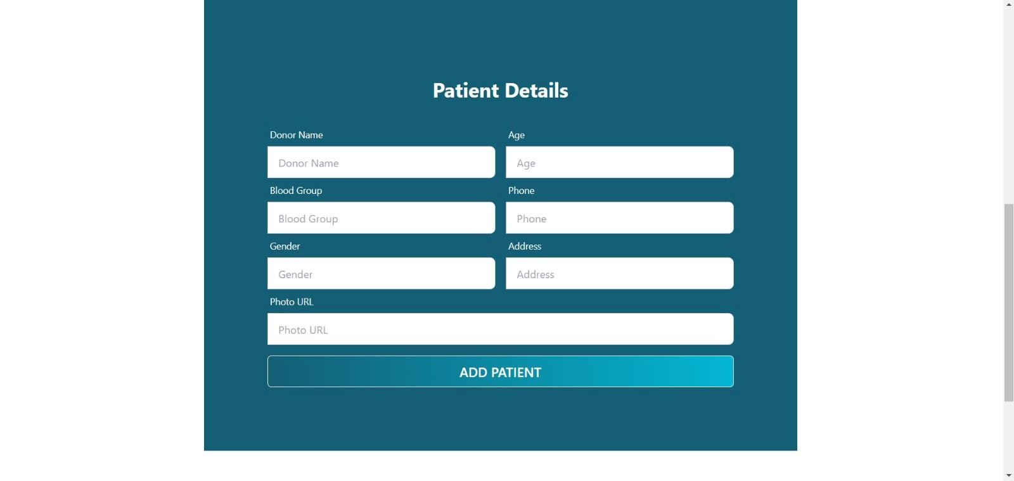

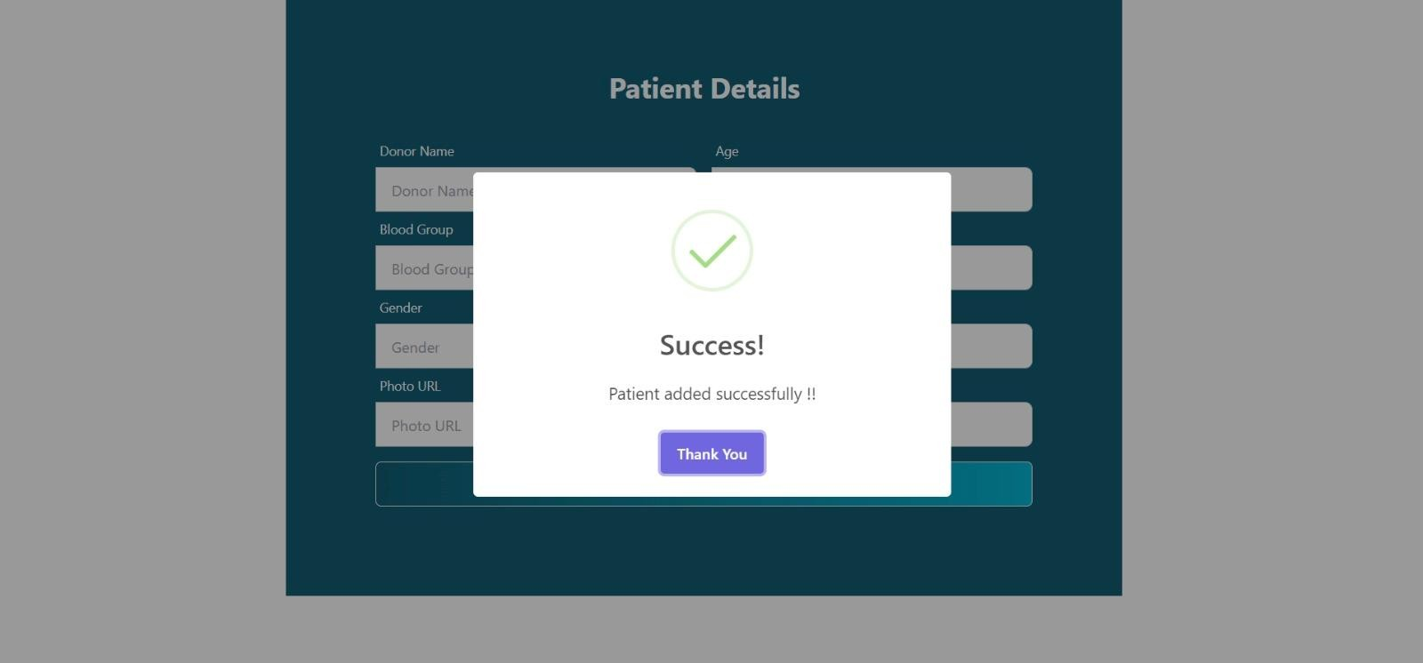

Contact

In contact page any one who wants to need or donate blood or gaining a information about this system then he/she can contact us. Here are the contact of our members.

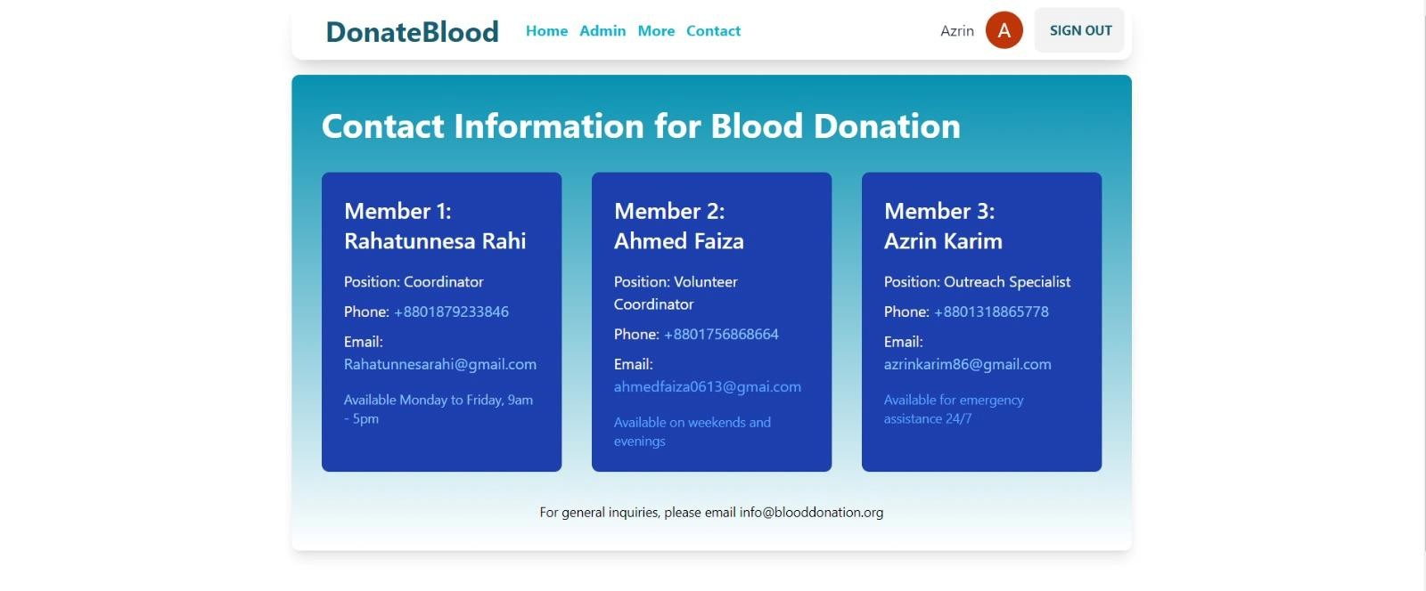

Inquiry

Here all the necessary information are mention in this section.

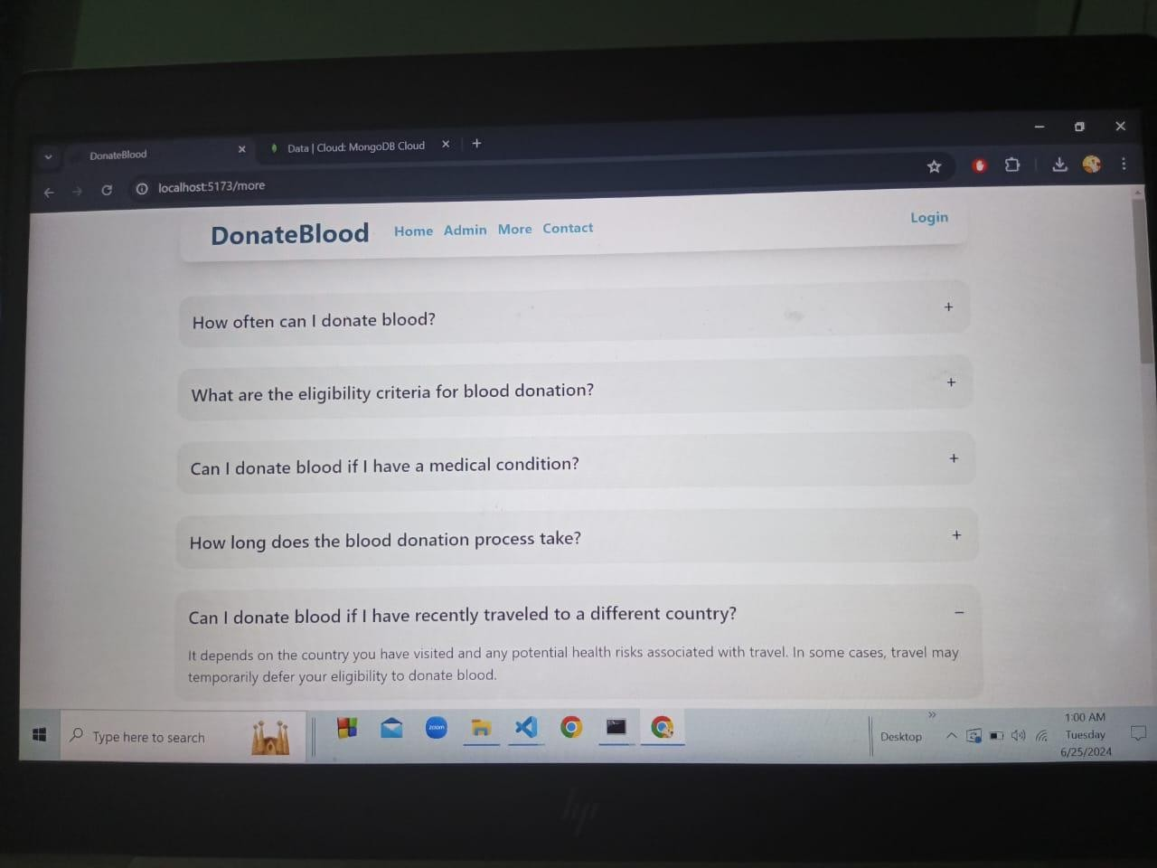

Feedback

Donor or patient can give their valuable feedback in this section. They can give their perspective about this website.

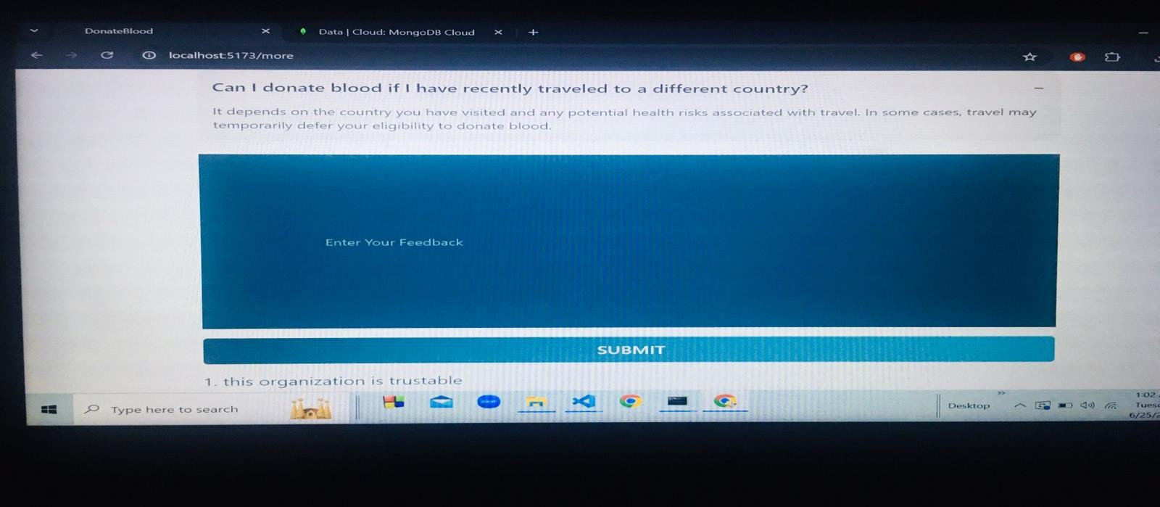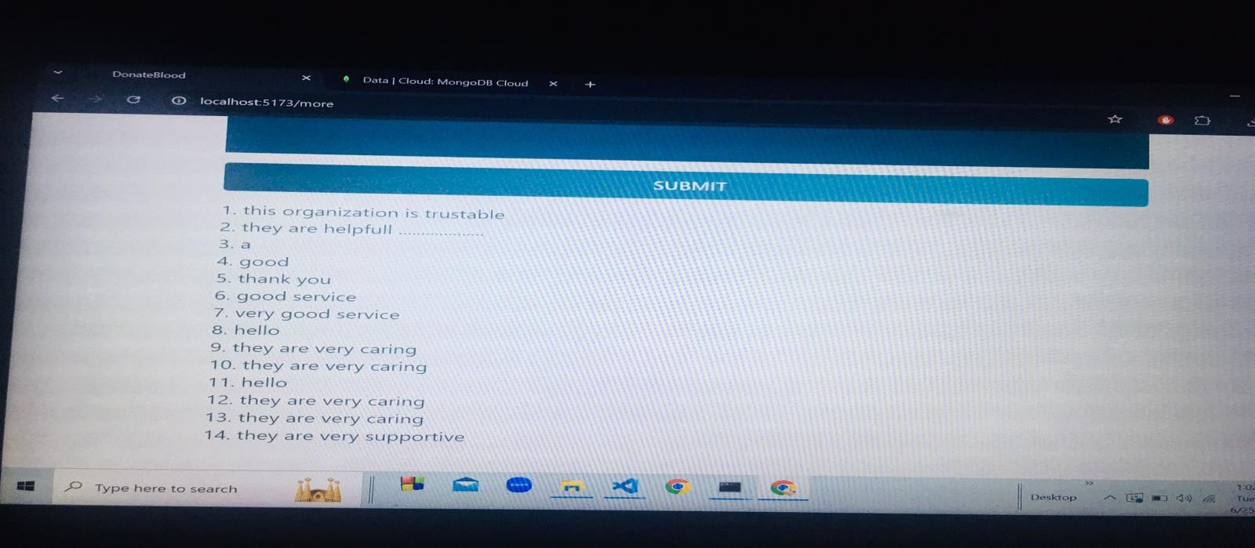

**Member’s Contribution**

# 

Rahatun Nesa Rahi

C231474

Banner Reviews Subscribe

Patient-Details Contact

Azrin Karim

C231466

Footer Login Signup

Authentication

Inquiry

Ahmed Faiza

C231465

Home Navbar Services

Donor-Details

Feedback Project-Report

# Conclusion

This Blood Donation Management System helps bridge the gap between blood donors and patients in need. By making it easy to register, find donors, and manage donation records, the platform supports a faster and more organized response in emergencies. It also encourages more people to donate by raising awareness and providing a user-friendly experience. Overall, the project aims to save lives by improving how blood donations are managed and accessed.